KeepBack
A small backup solution

Author: Chris Capon

2011-09-11

Licensed under GNU General Public License version 3.0

Table of Contents
About 3
Getting Started 4
Installing the software 4
Download 4
Installation 4
Runtime Environment 4
Command Line Options 4
Configuration file 5
Purpose 5
Creating a new file 5
Editing the backup set 7
Adding a new archive 7
Backup Sets 7
Adding an Archive 8
Selecting an Archive folder 9
Merging dated backups 9
Adding a folder 10
Selecting a directory 10
Folder Properties 11
Defining filters 11
Include, Exclude, Backup Once 11
Patterns 13
Radio Buttons 14
Completion 14
Saving changes 15
Folder 15
Archive 15
Save the Backup Set 16
Day-to-Day Operation 17
Frequency 17
Selecting a Control File 18
Launching the Backup 19
Cancelling and Restarting 21
Finalizing 21
Turn off your drive 21
Support 21

About
KeepBack is a small backup application. It is used to archive files and directories to USB hard drives or to Network Attached Storage (NAS) drives.
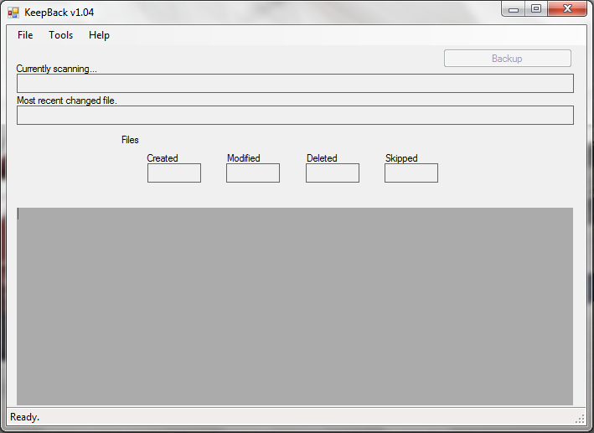
KeepBack is intended for the home user and has these features:
- Keeps historical copies
Copies of all of your documents are maintained going back in time. If disaster strikes and your current file becomes corrupt, an older copy may save the day.
- Reverse incremental backups
With KeepBack, the most recent backup is a complete replica of all your current files. Older backups only have copies of files that changed from one backup to the next.
- Can be safely interrupted
While underway, backups can be stopped at any time without concern and restarted at a later date. Files already preserved, stay preserved. Only outstanding changed files will be backed up when KeepBack is launched again.
- Automatic maintenance of backup sets
KeepBack has a system in place to merge older backups to conserve disk space. This is done over time based on a schedule you set.
- Portable across platforms
Written in C#, KeepBack can be run on any system which supports the .NET platform. This includes systems which support the Mono run-time environment. KeepBack has been tested on Windows XP, Vista, Windows 7 and Debian GNU/Linux.

Getting Started
The first step is to download and installing the software.
Before launching a backup, you need to tell KeepBack what to preserve and where to store backups. KeepBack uses control files to hold this information and they can be stored anywhere on your system.
Backups can be launched on a regular basis, either once a week, once a day or even several times an hour, depending on your needs.

Installing the software

Download
The software is available for download on the SourceForge project site. There is an archive for the source and a single download for the executable.
Select the latest version and download it.

Installation
KeepBack is a single executable and does not need to be installed to a particular location. All settings are maintained in a configuration file with a .keep extension so KeepBack can also be run as a portable application.
There is no installer, so locate the KeepBack.exe file in a convenient place and run it from there.

Runtime Environment
In addition to the executable, KeepBack requires the Microsoft .NET platform v2.0 or greater for the runtime environment. On non-Windows platforms, a current release of the Mono .NET environment will be sufficient.
With the Mono environment, start the application using the runtime launcher:
mono KeepBack.exe

Command Line Options
There is one command line option – the path to a configuration file. If provided, KeepBack will start with that configuration file selected, otherwise, one can be chosen from the interface.
Eg:
KeepBack.exe D:\Backup\MyConfig.keep
mono KeepBack.exe /home/user/myconf.keep

Configuration file

Purpose
A configuration file is a container of information that tells KeepBack which files you would like to preserve and where you would like to store the backup archive.
You can have any number of configuration files, but usually there will be one per computer. The files have a filename extension of .keep and can be stored anywhere accessible.

Creating a new file
When preparing for a backup, a configuration file must be created to hold the configuration information. For your first backup, this file must be created and stored in an accessible location.
The first step after starting KeepBack is to select File / New from the menu:
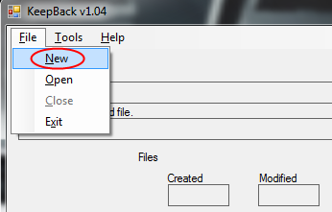
The file select dialog will open. Locate the folder and provide a name for where you want the configuration file stored. A good location is on the media where you will store your backup archive.
This is also a good time to create a folder for your archive to be stored in.
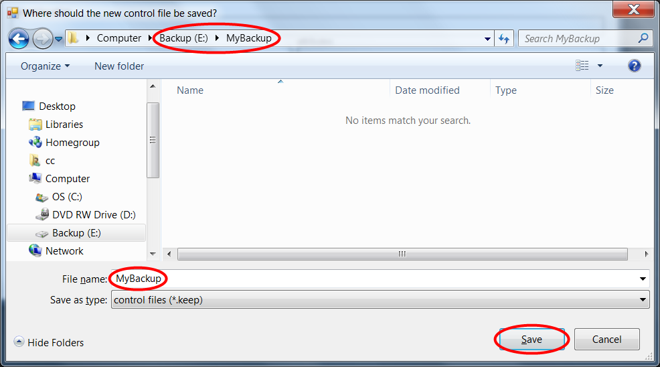
Once you click the Save button, an empty configuration file is created and KeepBack returns to the main screen ready for the next step.

Editing the backup set
To modify the configuration file, start at the main KeepBack screen. The name of your configuration file will appear at the top on the application’s title bar. If no filename is shown, click the Open button and select a .keep file for your backup set.
When ready, click the Edit button and a new screen will appear where you can modify your backup set.
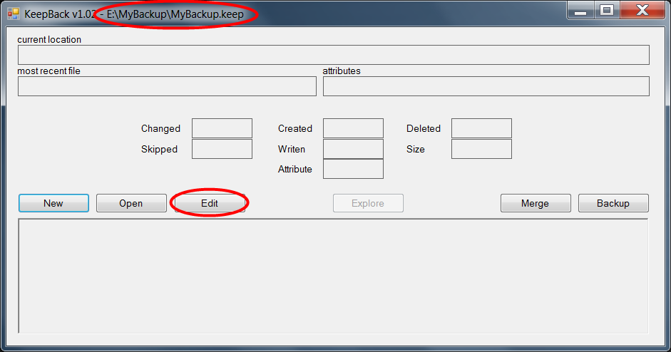

Adding a new archive

Backup Sets
A Backup Set consists of one or more Archives, and an Archive is a collection of files being backed up to one place.
Usually, a single computer will have just one Archive for all its files, but you might want different directories archived to different storage locations. In that case you can create multiple Archives in your Backup Set.

Adding an Archive
A new, empty Backup Set will not have any Archives defined. To add an Archive, click the green plus sign (+) on the right side of the screen.
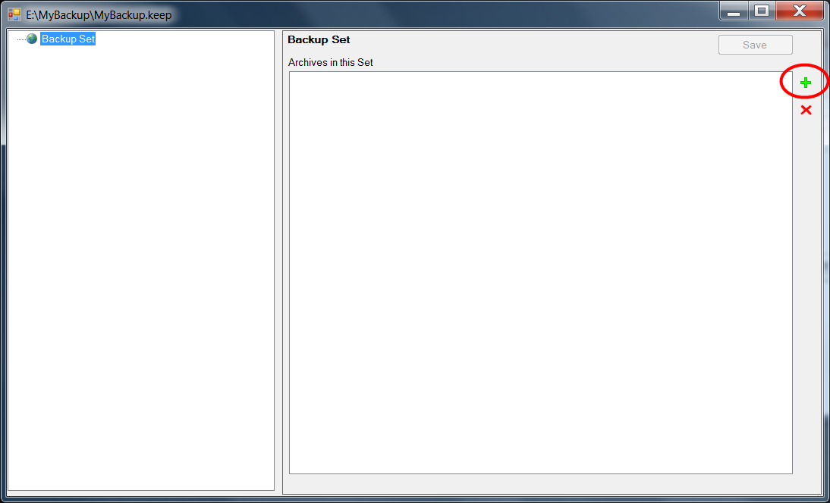
The next panel that opens can be used to define the properties of the Archive.

Selecting an Archive folder
Start by selecting a directory in which the Archive will be stored. On the right hand side, click the yellow folder icon to create or locate a folder on your backup drive for the Archive.
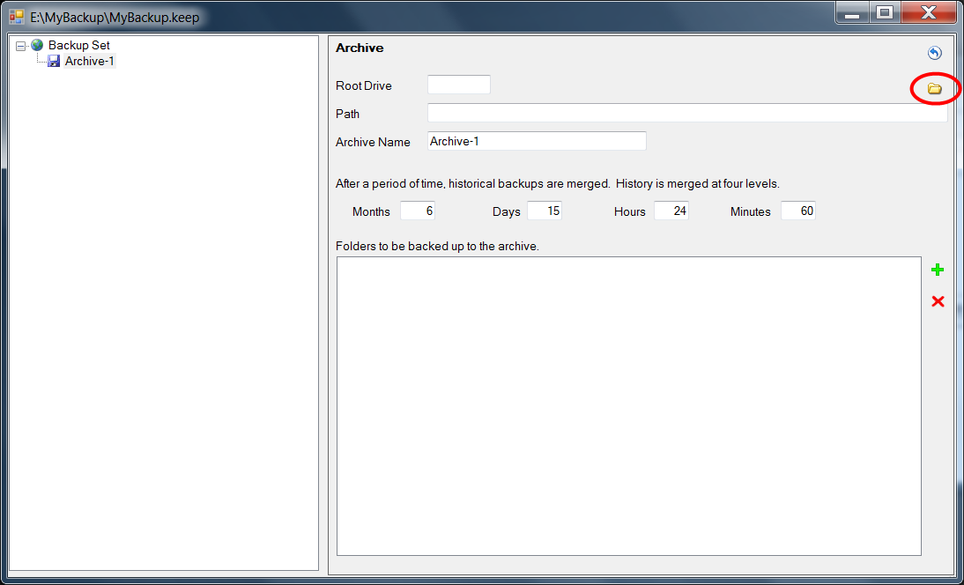
Once you have selected a folder, the top fields will be filled in with the drive and directory path, while the Archive Name will be derived from the last folder name in the path.

Merging dated backups
When backups are performed, each one will be stored in a folder named after the current date inside the Archive directory. The most recent dated folder contains all of your current files, while older ones contain just files which have changed over time.
Backups can take a lot of disk space and it generally isn’t necessary to keep all possible copies of all files for all time. Instead, a copy is made only if a file has changed since the last backup.
One way that KeepBack manages disk space is by merging older backups and eliminating duplicate files. Merging provides a reasonable balance between optimizing disk space and having good recovery choices for files that change. Each time a backup is performed, KeepBack first checks the older dated folders to see which can be merged.
Merging is done based on the Archive settings on this panel. In general, the default settings will be sufficient, but you can adjust them to suit your needs.
The Months field has a default value of 6, which means any backups older than 6 months will be merged in to a single yearly backup. Yearly backups are kept indefinitely.
The Days field has a default value of 15, which means backups older than 15 days will be merged in to a single monthly backup.
The Hours field has a default value of 24, which means backups older than 24 hours will be merged in to a single daily backup.
The Minutes field has a default value of 60, which means any backups older than 60 minutes will be merged in to an hourly backup.
Backups can be run as often as you like. Many backups done over the course of an hour will eventually be merged in to a single hourly backup to conserve space. Many hourly backups will eventually be merged in to a daily backup. Daily backups are merged in to monthly backups. Monthlies are merged in to yearly backups and yearly backups are preserved indefinitely.
If you are unsure what to change, leave the above fields at their default settings for now.

Adding a folder

Selecting a directory
Once the Archive is defined, it is time to add Folders. Folders specify the files and directories you want backed up to the Archive. In general, you don't need to back up all the files on your computer as many of them can be recovered by simply reinstalling software. Instead, select the files and folders with your critical data – like your documents and photographs. Some good candidates would be:
Operating System | Folder
Windows 7 | C:\Users
Windows XP | C:\Documents and Settings
Linux | /home

From the Archive panel, click the green plus sign (+) on the right side to add a new Folder.
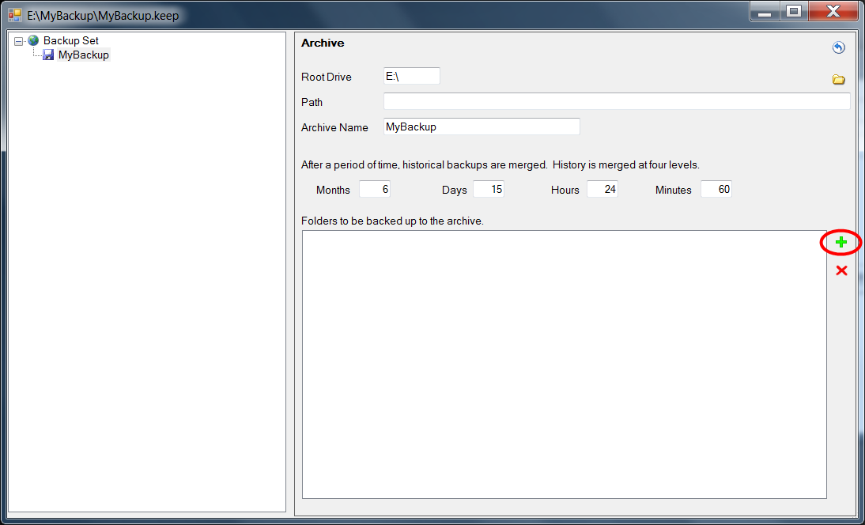

Folder Properties
The Folder panel allows you to specify more details about how a directory will be backed up. The Name field at the top will be used as the folder name in the Archive where the backup files are stored. They appear just under the dated folder when a backup is performed. An example might be if you want C:\Users backed up, a good Archive name for it would be Users.
On the right side, select the yellow folder icon to pick a path on your computer to be backed up. In the example above, you would select the C:\Users folder.
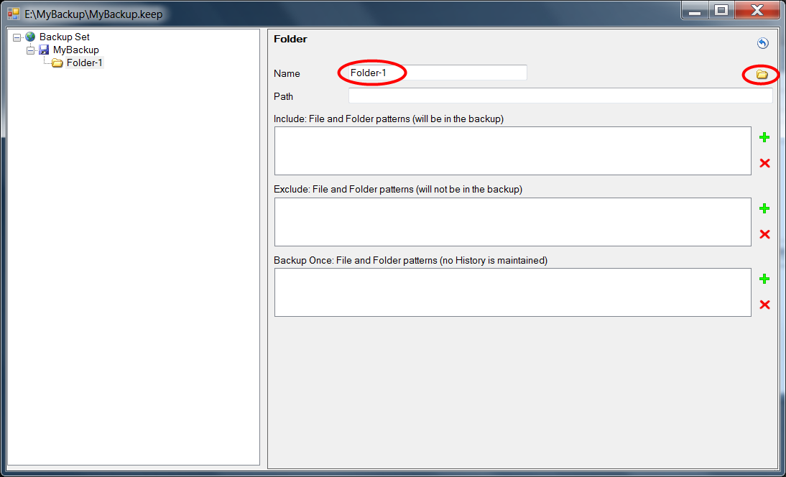
Once a folder is selected the Path field will be updated with the directory path. The name will also appear in the left hand navigation panel under the Archive.

Defining filters

Include, Exclude, Backup Once
For each backup folder, a series of filters can be defined which limit the files and directories that will be preserved in the archive.
An Include filter specifies that only these files or folders will be preserved. If no Include filters are provided then all files and folders are preserved. Generally, you won’t use this type of filter except in special circumstances.
An Exclude filter identifies files and folders which will not be included in the archive. This is the most common type of filter to apply. Use it to eliminate files you don’t need, like internet browser caches or temporary file folders.
A Backup Once filter is used specifically for files and folders which are to be included in the archive but for various reasons are not to have historical copies made. This filter would typically be used for large files – like video files or your E-Mail repository – which may change frequently but are too big to have multiple copies kept on your backup drive.
To add a new Exclude filter, click on the green plus sign (+) next to the Exclude filter list box.
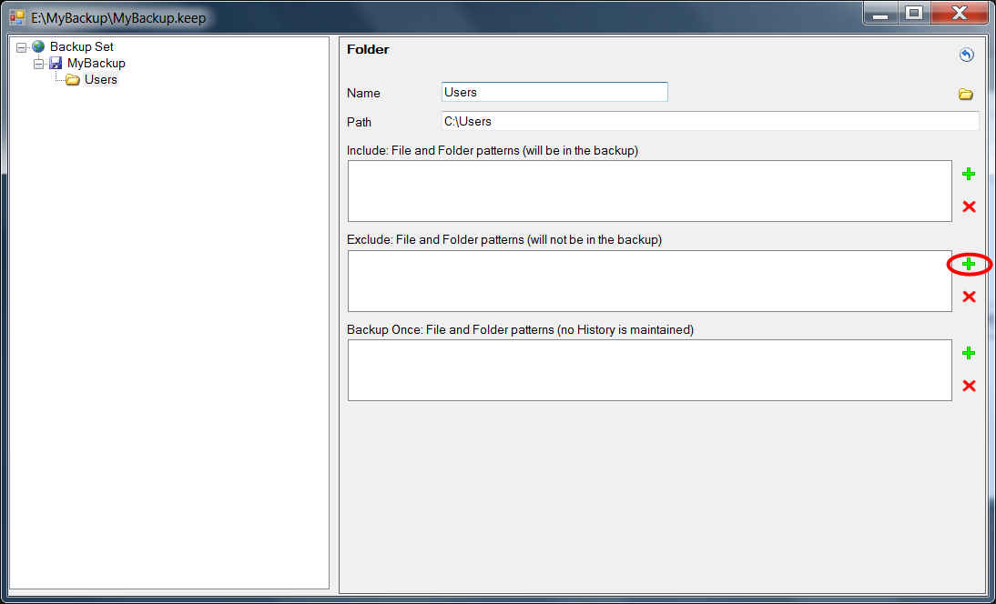
The Exclude filter panel will appear.

Patterns
The Pattern field at the top is used to match either files or folders. Anthing that matches will either be included, excluded or backed up once depending on the filter type being defined.
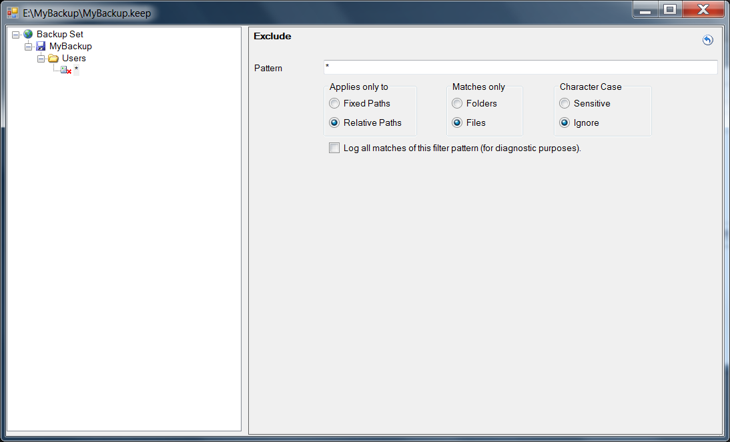
Filters use special characters to match many files, folders or combinations of both.
- Patterns can be simple, like the name of a file.
Example: MyDocument.txt
- Patterns can include replaceable characters.
  - star (*) replaces multiple characters.
Example: Fred*.txt
Matches: FredFlintstone.txt and Fred123.txt
  - question mark (?) replaces single characters.
Example: Fred?.txt
Matches: FredX.txt and Fred2.txt
- Patterns can include directory separators (/) or (\) along with multiple levels of directories.
Example: Documents/Temp/*.bak
- Patterns that start with a directory separator (/) or (\) are matched starting from the top level folder; in other words, a fixed path from the root folder.
Example: /Documents/Accounting/*.doc
- Patterns that do not start with a directory separator will match anywhere they are found in the hierarchy; in other words, a relative path found at any level.
Example: Cache/*
Matches: /Documents/Cache/* and /Browser/Temporary/Cache/*
- Patterns that end with a directory separator (/) or (\) match only directories, not files.
Example: Cache/Temp/
- Patterns that do not end with a directory separator match only files, not directories.
Example: *.bak
- A special pattern for matching any number of sub-directory levels is three periods (...) between directory separator characters.
Example: Cache/.../*.bak
Matches: /Browser/Temporary/Cache/Hidden/Folder/Files/system.bak

Radio Buttons
The radio buttons help with the last four rules above. They are used to set or remove the leading and trailing directory characters (/) and (\). They also identify how the filter will be applied.

Completion
When finished, use the blue return arrow in the top right corner to return to the Folder panel. The left side navigation panel can also be used to move about by clicking on any level.
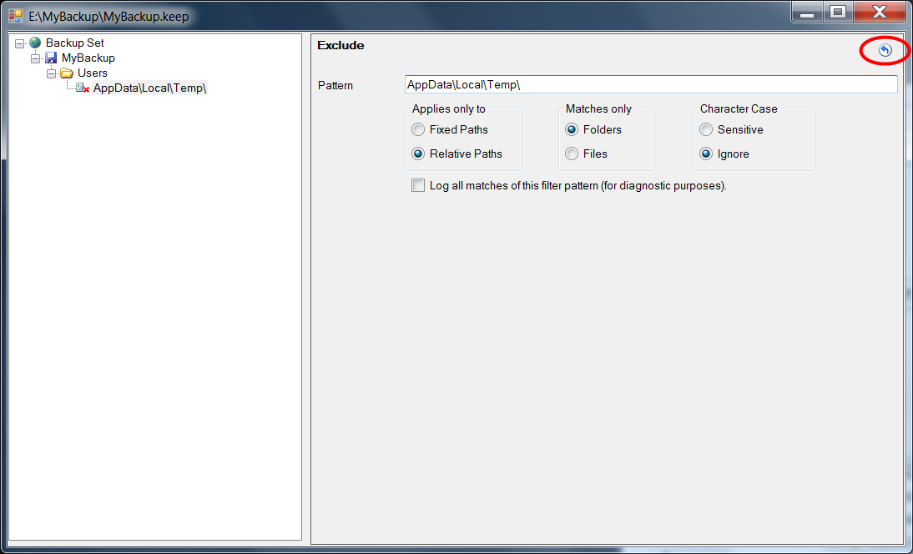

Saving changes

Folder
At the Folder panel, you can add more Include, Exclude or Backup Once filters using the green plus (+) buttons as necessary.
If you need to remove a filter, first select it by clicking on it in the filter list, then click the red X (x) button next to the list.
When finished setting filters, use the blue return icon in the top right corner to return to the Archive panel.
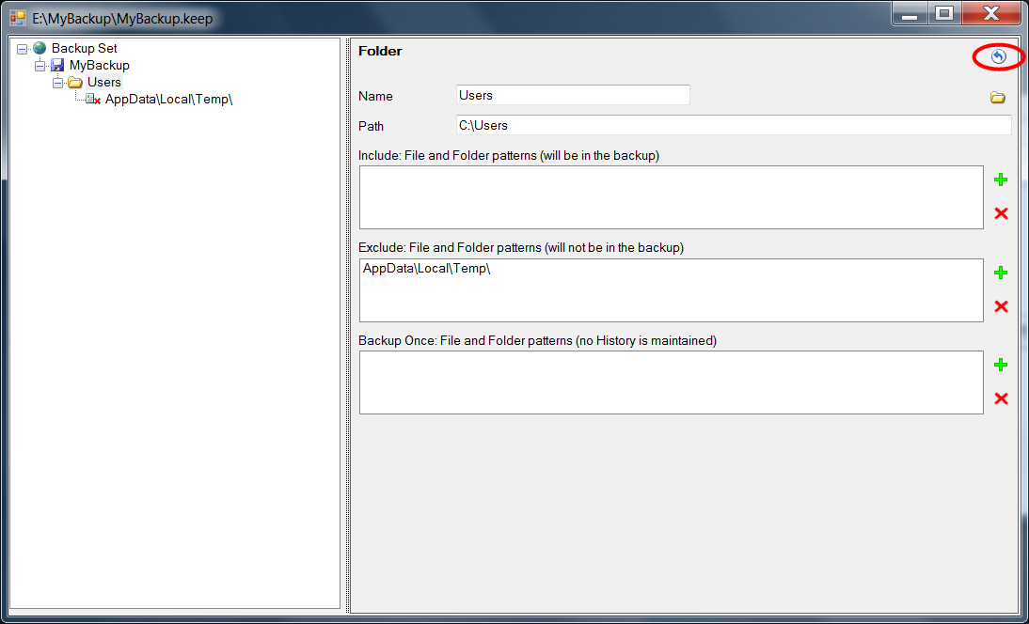

Archive
At the Archive panel, you can add more folders as necessary to ensure all your data will be preserved.
If you need to remove a folder, first select the folder in the list by clicking on it once, then click the red X (x) on the right side of the list.
When finished, return to the Backup Set panel using the blue return button in the top right corner of the panel.
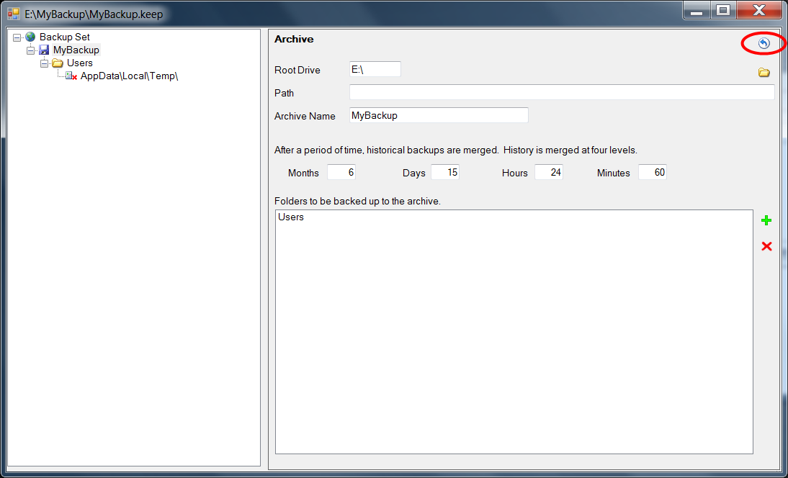

Save the Backup Set
At the Backup Set panel, it is possible to add more archives. Generally, you will only have one archive unless you need to back up different directories on your computer to different locations.
The last step is to save the Backup Set. Simply closing the window will prompt you to save any changes, but from this panel the Save button can be clicked to save changes without leaving the maintenance screen.
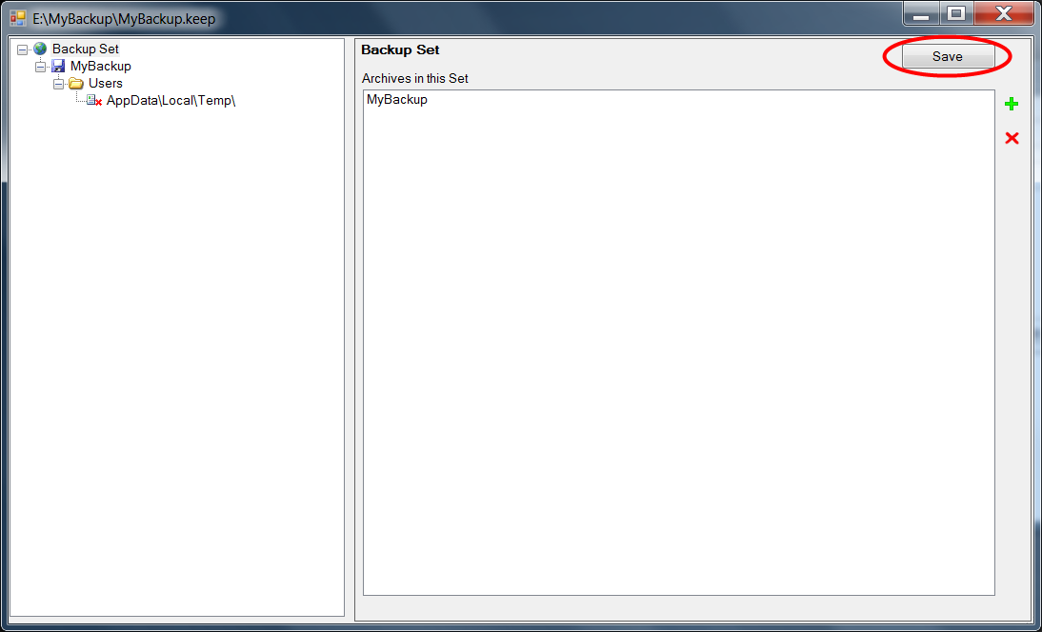
When ready, close the panel to return to the main KeepBack screen.

Operation

Frequency
Periodically (every day, week or month) you should launch a backup. It is up to you to decide how often you will run a backup. Usually the decision is a balance between convenience and risk. The longer you go without a backup, the more data you stand to lose if your hard drive fails.
Generally speaking, you shouldn’t go more than a week without launching a backup.

Selecting a Control File
Launch KeepBack, then select the control file you created for the backup. Click the Open button and locate the .keep file.
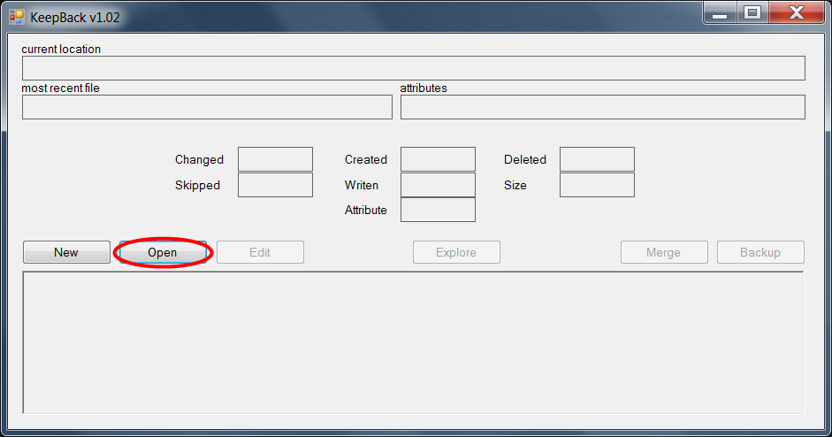

Launching the Backup
When you are ready, click the Backup button to start the process.
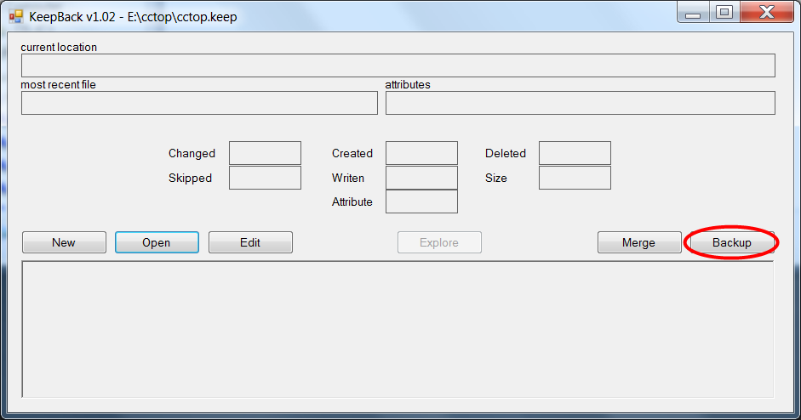
Your first backup will take a long time to run. A copy of every file must be made to the backup media. Subsequent backups will be much faster because only files that changed will be copied. For your first backup, please be patient and allow lots of time.
The first step in the backup process is to merge existing backup sets. For your first backup, there is nothing to merge, but on subsequent backups the merge process will combine previous backups to conserve disk space.
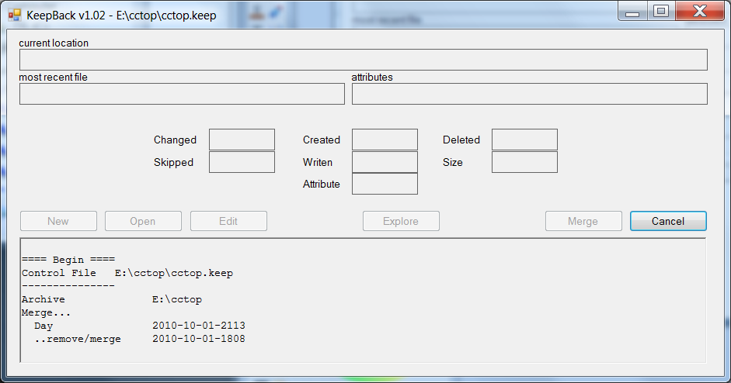
After merging, the main backup process begins. KeepBack looks for files which have been added, changed, or deleted, then copies those files to the backup media.
A new dated folder will be created in the archive for this backup and it will contain the most recent copy of every file. Earlier folders in the archive will contain only copies of files which have changed over time.

Cancelling and Restarting
The backup process can be interrupted at any time by clicking the Cancel button. KeepBack will finish the file it is working on, then stop.
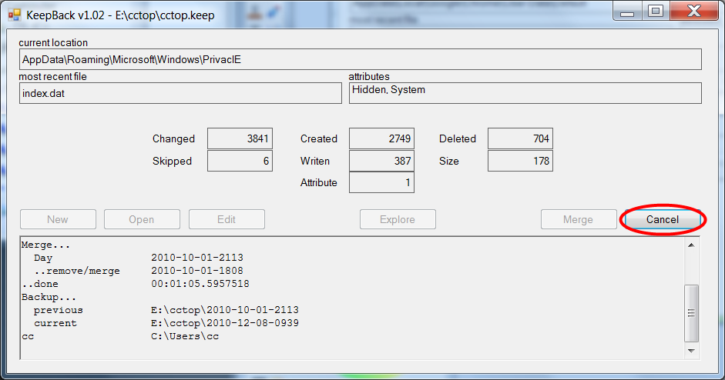
To resume, just follow the above steps to start a new backup. KeepBack will scan for changes and pick up where it left off from the last time.

Finalizing
With your backup complete, the job is done. KeepBack can be shut down until it is time for the next backup. Take the time to look over your archive folder and get familiar with the file layout. It is always a good idea to verify that the backup worked and the files you need are preserved.
A log file for each backup is kept in the archive folder. You can review it for any error messages and to see which files have changed since your last backup. If any files were skipped during the back process, here is where you will find further information on why they were skipped. Usually it will be for the reason that KeepBack does not have permission to access the file or it is in use by some other application.

Turn off your drive
When using a USB hard drive as your backup media, it is a good idea to turn the drive off when not in use. USB drives should be safely unmounted using your operating system’s controls, then shut down. By leaving the drive off or disconnected when not in use, your archive will be protected from accidental corruption should a disaster hit your computer.

Support
KeepBack has a SourceForge page with further details and information.
If you have a question or would like to see what others are saying about KeepBack, visit the support forums.
When reporting bugs, please check the tracker to see if the problem has already been documented. If not, feel free to create a new issue.

